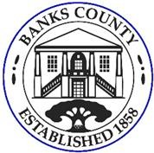 | BANKS COUNTY PARKS AND RECREATION ADVISORY BOARD MEETING
 | Courthouse Annex | 150 Hudson Ridge | Homer, GA 30547
 | Wednesday, November 12, 2025 at 5:00 PM
 | AGENDA

- Call To Order
- Approval of Agenda
- Approval of Minutes
  - October 15, 2025
- Old Business:

- New Business:
  - Grant Opportunity ideas
  - Park Enhancement Ideas
  - Board Meeting Schedule Format
- Staff Reports:
  - Programs and Operations- Assistant Director
  - Director Report
- Public Comment
- Adjournment

